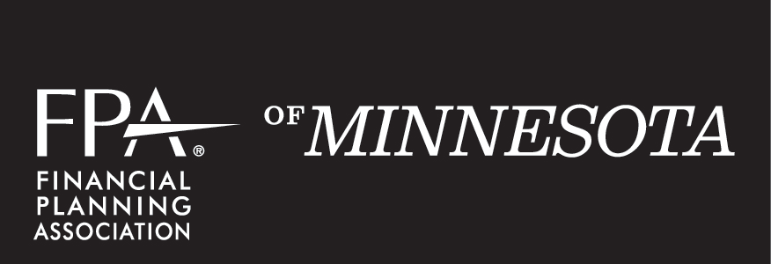

2020 PRO BONO - Plan of Work
FPA is the community that fosters the value of financial planning and advances the practice and profession of financial planning.

Director: | Bruce Lorenz
Vice: | Tiffany Walker (interim) | TBD

Committee Members:
San Asato | Melanie Hardie
Steve Gilbertson | Jerry Lund

PASSION STATEMENT
Making wise financial decisions aligned with one’s values is a defining part of a fulfilling life. As such, we believe that every individual and family deserve access to quality financial planning services, regardless of their financial means or background.

We passionately serve the underserved members of our community. We believe that the most effective way to advance the practice and profession of financial planning is to share its power with those in need in our community, and that in doing so we GROW as much as we GIVE. This is why we actively work to build relationships with Community Based Organization (CBO) partners, connecting members of underserved communities with opportunities to engage in pro bono financial planning engagements with the nearly 300 qualified CFP® practitioner members of FPA of Minnesota.

3 MAIN STRATEGIES
As a guide, strategies are not specific projects.
Strategy 1 | Provide EDUCATION, tools and resources for the community of CFP® practitioners to serve the unique needs of underserved communities and individual and families in times of crisis.
How will we communicate with our targeted audiences? | By providing educational content through regular workshops, participation in Twin Cities Financial Planning Day and vetted resources.

Tactics to Fulfill Strategy | Target Date | Committee Member(s)  Spearheading | Value that should be Communicated
Pro Bono Workshop February 2020 – Financial Cancer Care training | February 18 | TBD | Training specific to the needs of cancer patients and their families. Co-hosted by CBO partner Angel Foundation.
Pro Bono Workshop June 2020 – Topic TBD | June 16 | TBD | Tools and resources for providing financial planning to individual and families with a specific need commonly addressed in the context of a pro bono financial planning engagement.
Pro Bono Workshop #3 – Pro Bono Training | TBD | TBD | FPA Pro Bono Training – Fundamentals of facilitating a pro bono consultation.
Maintain vetted community resource list | Ongoing | Melanie Hardie | Provide referral organizations for advisors working with Pro Bono consultations.
Ways to Integrate Ideas and Collaborate
How does what you do integrate with what other committees/organizations do?
Alliance | What can we provide? | What can they provide?
Foundation for Financial Planning | Access to volunteers, guidance and support to grant recipients, outcome stories. | Grant funding, access to a national network of CBO resources.
Financial Education Committee | Shared content and relationship management with Community Based Organizations. | Drive attendance at events containing both pro bono and financial education content, including TCFPD. Content, speakers and resources for events.
Career Development, Member Experience | A way to deepen a (new) member’s connection with FPA. | Assistance with finding new CFP® practitioner volunteers and pro bono committee members.
PR Committee | Impact stories for newsletter and social media campaigns that illustrate the value of the financial planning profession to the public. | Increased visibility into pro bono committee efforts, with the goal of facilitating member engagement and volunteer recruitment.

Strategy 2 | Connect our members with meaningful volunteer opportunities that will deepen their ENAGEMENT with the COMMUNITY of other financial planning practitioners, GROW their planning skills/knowledge, and promote the profession of financial planning as they GIVE back to residents of the Twin Cities and greater Minnesota.
How will we communicate with our targeted audiences? | Through one-on-one interactions and public speaking opportunities at social, educational and volunteer events throughout the year, the FPA MN newsletter and social media accounts, as well as ad hoc email communications distributed by the FPA MN Volunteer Director.

Tactics to Fulfill Strategy | Target Date | Committee Member(s)  Spearheading | Value that should be Communicated
Work with the Volunteer Director and Financial Education Committee to organize and promote CBO participation and connect them to members interested in volunteer opportunities. | Ongoing | All | When you GIVE of your time and talents, you GROW even more.
Twin Cities Financial Planning Day | September 26 | All | Promote the value of pro bono financial within the Twin Cities community.
Pro bono committee member recruitment | Ongoing | All | Being a pro bono committee member is a fun and fulfilling way to promote the practice and profession of pro bono financial planning.
Fully implement volunteer database, and inform technology integration efforts being undertaken by OneFPA as part of the OneFPA Network initiative | Ongoing | Volunteer Director, Tiffany Walker | FPA MN will communicate regarding volunteer engagement opportunities in a consistent, targeted, efficient way.
Recognize and promote outcomes of volunteer activities in a timely manner | Ongoing | Volunteer Director, All Committee members | The efforts of our volunteer members are impactful and valued.
Include CBO’s in FPA MN social events, including volunteer appreciation events | Ongoing |  | We appreciate our community partners!

Ways to Integrate Ideas and Collaborate
How does what you do integrate with what other committees/organizations do?
Alliance | What can we provide? | What can they provide?
CFP Board/OneFPA | Commitment to the value of the CFP® designation, structured volunteer opportunities. | Technology and marketing tools to facilitate and support engagement with CFP® practitioners regarding pro bono volunteer opportunities.
Foundation for Financial Planning | Access to volunteers, outcome stories. | Grant funding, access to a national network of CBO resources.
Public Relations | Engaging success stories and content in a timely way. | Increased public awareness of and enhanced member engagement with FPA MN pro bono activities.
Member Experience | A meaningful way for CFP® practitioner members to deepen their engagement with FPA MN. | Opportunity to engage with FPA MN membership, assist with recruitment of volunteers.
Financial Education | Shared support of Volunteer Director activities. | Help organize and promote volunteer engagement opportunities.

Strategy 3 | Provide opportunities for our CFP® practitioners to offer pro bono advice to the public
How will we communicate with our targeted audiences? | Develop and nurture relationships with new and existing CBO partners aligned with FPA’s primary aim

Tactics to Fulfill Strategy | Target Date | Committee Member(s)  Spearheading | Value that should be Communicated.
Support efforts to provide pro bono financial planning and training to FPA MN member and the public outside the Twin Cities metro area | Ongoing | Bruce Lorenz | Growing FPA MN’s presence in greater Minnesota is an important initiative for the organization.
Vet and onboard new organizations to grow our CBO partner network, and add them to the list of community resources pro bono volunteers and recipients can access. | Ongoing | All | FPA MN can deliver pro bono financial planning as a supplement to the CBO’s existing programming, and is an integral part of the Twin Cities and greater Minnesota community.
Coordinate CBO management with Financial Education Committee efforts. | Ongoing | All | We need to deliver consistent value to our current CBO partners, and create an intra-committee structure that allows for accountability within each CBO relationship.
Ways to Integrate Ideas and Collaborate
How does what you do integrate with what other committees/organizations do?
Alliance | What can we provide? | What can they provide?
Programs Committee | Pro bono programming and training | Opportunity to deepen relationship with members in greater MN.
Financial Education Committee | Collaboration with CBOs, volunteers and educational materials | Collaboration with CBOs, volunteers and educational materials.
PR Committee | Content to share regarding how we can help CBOs. | Distribution through social media, website, articles, etc.

