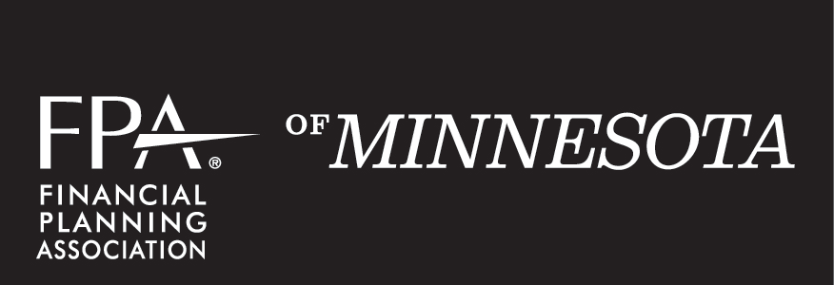

2018 CAREER DEVELOPMENT COMMITTEE - Plan of Work
FPA is the community that fosters the value of financial planning, and advances the practice and profession of financial planning.
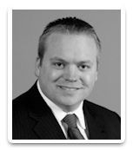
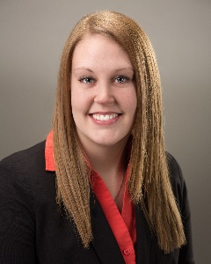

Director: | Nick Thunker | nthunker@silveroakwealth.com
Vice: | Open

Committee Members:
Chloe Briel | Jenna Ecker | Dan Hiebert
Sara Kantor | Molly Sullivan

PASSION STATEMENT
The Career Development Committee is dedicated to supporting the FPA in its efforts to build a strong professional community, especially through those new to the profession.
3 MAIN STRATEGIES
As a guide, strategies are not specific projects.
Strategy 1 | Engage career changers
How will we communicate with our targeted audiences? | Through FPA Connect, email, PR Committee, Chapter meetings, visits to CFP courses, newsletters, other FPA members.

Tactics to Fulfill Strategy | Target Date | Committee Member(s)  Spearheading | Value that should be Communicated.
Continue to be in touch with Financial Planning Program night classes – St. Thomas and Mankato | Ongoing – 6/1 | Nick | Communicate the value of FPA to the students in programs: education, networking, connecting, job centers, mentorship opportunities, resume resources, tools.
Career Day | 2/18 | Nick | Ability to interview with hiring firms, end-of-day speaker, roundtable discussions.
Promote scholarship opportunities | 12/31 | Megan | Communicate value of all available scholarships: Montgomery, Residency, Symposium, Kaplan, scholarships that are available through the CDC.
Ways to Integrate Ideas and Collaborate
How does what you do integrate with what other committees/organizations do?
Alliance | What can we provide? | What can they provide?
PR Committee | Provide content to push out on social media pages | Assistance in getting the word out about FPA and the benefits to career changers.
Kaplan | Exposure to students in CFP® programs, show value of membership, advertisement on the website | Scholarships for exam prep possible, class time to speak to students.
New Member Committee | Potential new FPA members | Collaboration to visit financial planning program classes to communicate value of membership.

Strategy 2 | Engage undergrad students
How will we communicate with our targeted audiences? | Through FPA connect, email, PR Committee, University Career Centers, professors, school visits, newsletters, other FPA members.

Tactics to Fulfill Strategy | Target Date | Committee Member(s)  Spearheading | Value that should be Communicated.
Promote scholarship opportunities | 12/31 | Megan | Communicate value of all available scholarships: Montgomery, Residency, Symposium, Kaplan, scholarships that are available through the Career Development Committee.
Continue connections with University Partner Program at Mankato | Ongoing – 12/31 | Nick | FPA (MN and National) resources to be shared with the university. Make trips to continue relationship communication.
Continue connections with University Partner Program at UMD | Ongoing – 12/31 | Megan | FPA (MN and National) resources to be shared with the university. Make trips to continue relationship communication.
Career Day | 2/18 | Nick | Ability to interview with hiring firms, end-of-day speaker, roundtable discussions.
Explore local university setting up Financial Planning program | 6/30 | Megan | FPA (MN and National) resources – how can a university benefit from a financial planning program?
Ways to Integrate Ideas and Collaborate
How does what you do integrate with what other committees/organizations do?
Alliance | What can we provide? | What can they provide?
PR Committee | Provide content to push out on social media pages | Assistance in getting the word out about FPA and the benefits to career changers
Kaplan | Exposure to students in CFP® programs, show value of membership, advertisement on the website | Scholarships for exam prep possible, class time to speak to students
NexGen Committee | Additions of NexGen members | Introduction to NexGen community
General Membership | Opportunities to play a volunteer role for members that have connections with local universities | Connections to local schools/professors/etc. to provide an opportunity to explore setting up a financial planning program.

Strategy 3 | Improve current member experience relative to the Career Development Committee
How will we communicate with our targeted audiences? | Through FPA Connect, email, PR Committee, Chapter meetings, visits to CFP courses, newsletters, other FPA members.

Tactics to Fulfill Strategy | Target Date | Committee Member(s)  Spearheading | Value that should be Communicated.
Enhance job site/resume posting | 6/30 |  | Ability to review job postings and post/review resumes of those looking for work in the industry.

Ways to Integrate Ideas and Collaborate
How does what you do integrate with what other committees/organizations do?
Alliance | What can we provide? | What can they provide?
PR Committee | Provide content to push out on social media pages | Assistance in getting the word out about , publicity of need for new volunteers
FPA National/other FPA Chapters | Feedback with our current/ongoing experiences | Provide explanation and feedback on current programs

